Test Case: tc001_SPX_Dev5_Validar_Filtro_Campo_MenuName_Administrador_Roles_Menu
Step 1 - Enter username and password and click to button Enter : Credentials Entered
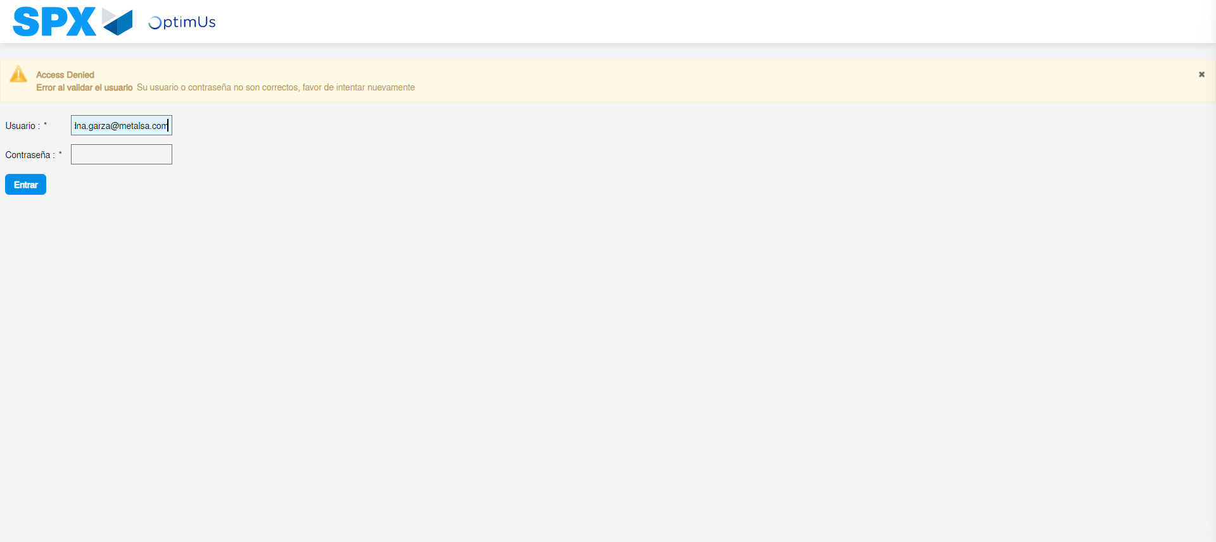Image file-name: QC_Testing-tc001_SPX_Dev5_Validar_Filtro_Campo_MenuName_Administrador_Roles_Menu-may. 15 2024, 12 57 15 p. m.

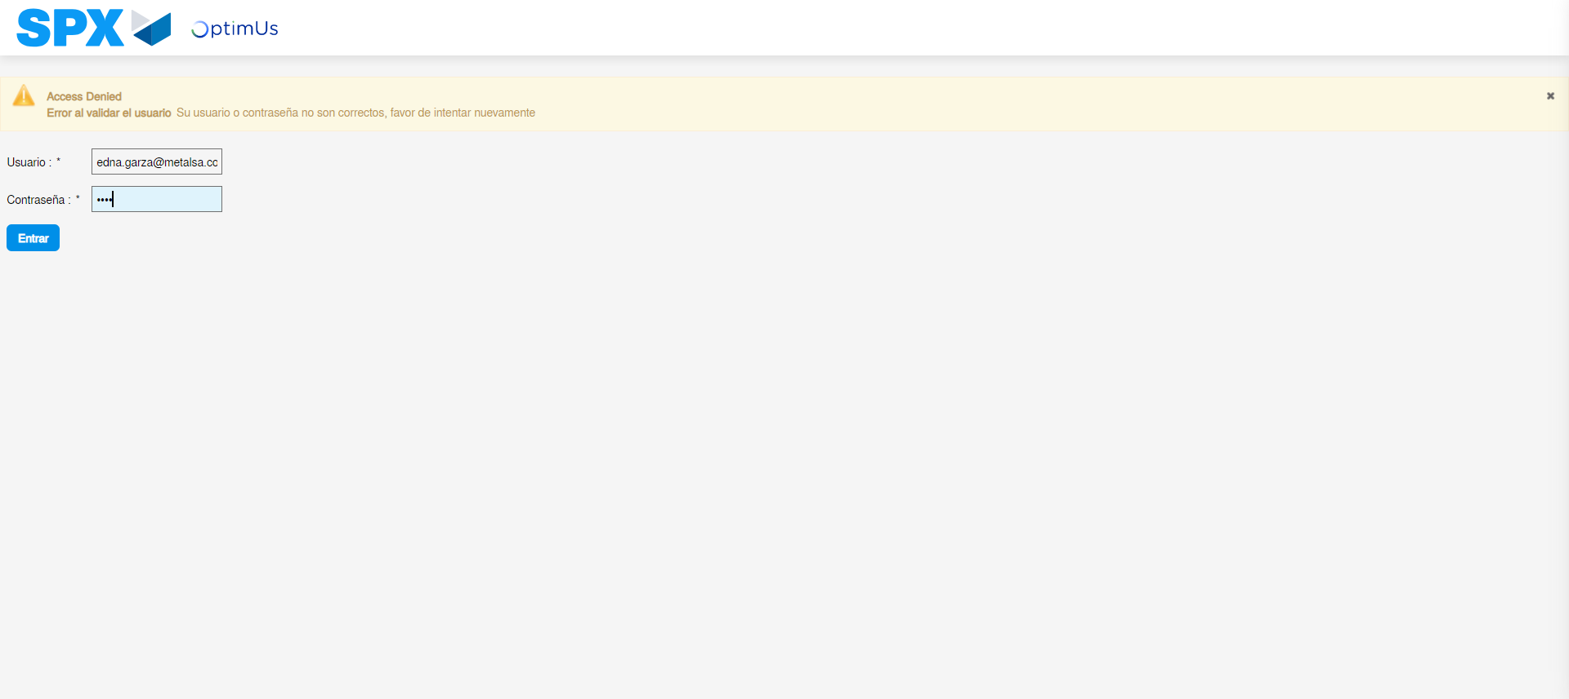Image file-name: QC_Testing-tc001_SPX_Dev5_Validar_Filtro_Campo_MenuName_Administrador_Roles_Menu-may. 15 2024, 12 57 16 p. m.

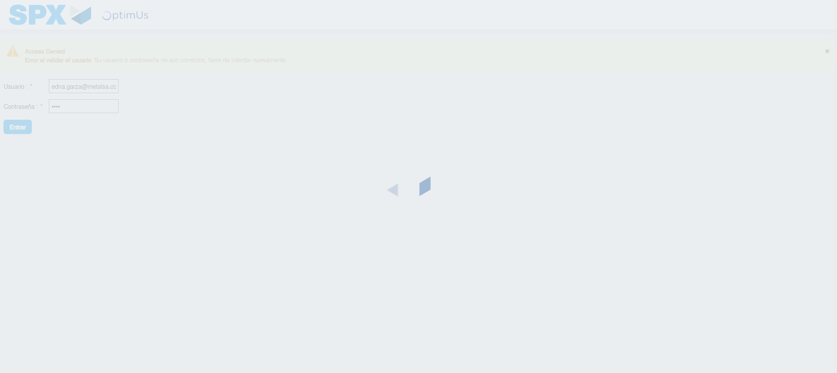Image file-name: QC_Testing-tc001_SPX_Dev5_Validar_Filtro_Campo_MenuName_Administrador_Roles_Menu-may. 15 2024, 12 57 17 p. m.

Step 2 - Select to UEN and Access to Administrador Roles Menu: UEN Correctly selected and Correct access
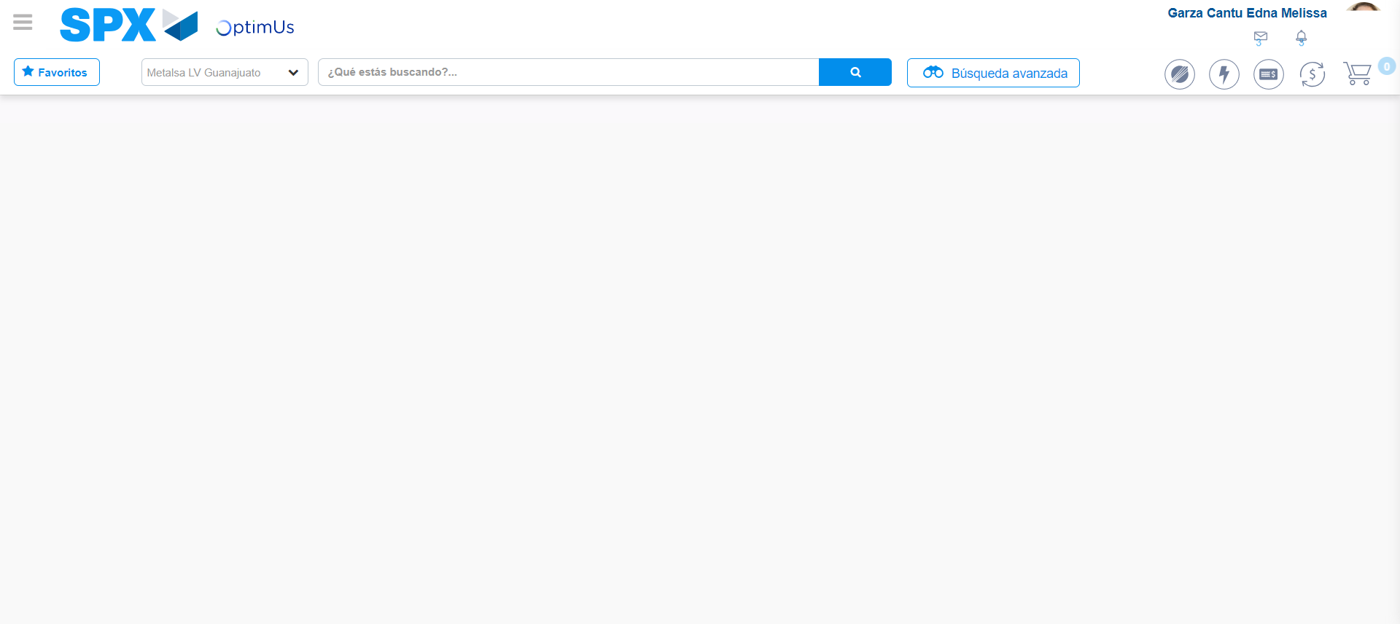Image file-name: QC_Testing-tc001_SPX_Dev5_Validar_Filtro_Campo_MenuName_Administrador_Roles_Menu-may. 15 2024, 12 57 23 p. m.

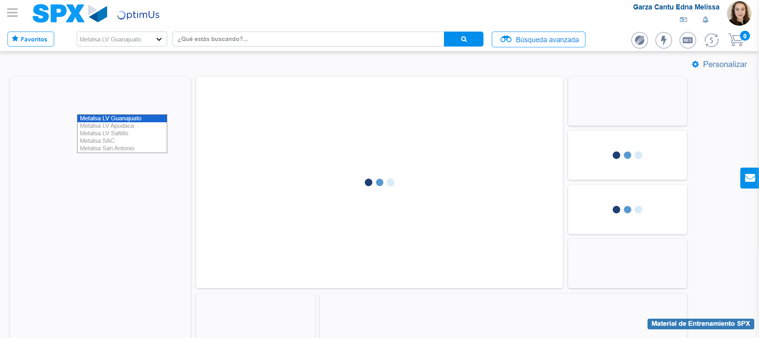Image file-name: QC_Testing-tc001_SPX_Dev5_Validar_Filtro_Campo_MenuName_Administrador_Roles_Menu-may. 15 2024, 12 57 24 p. m.

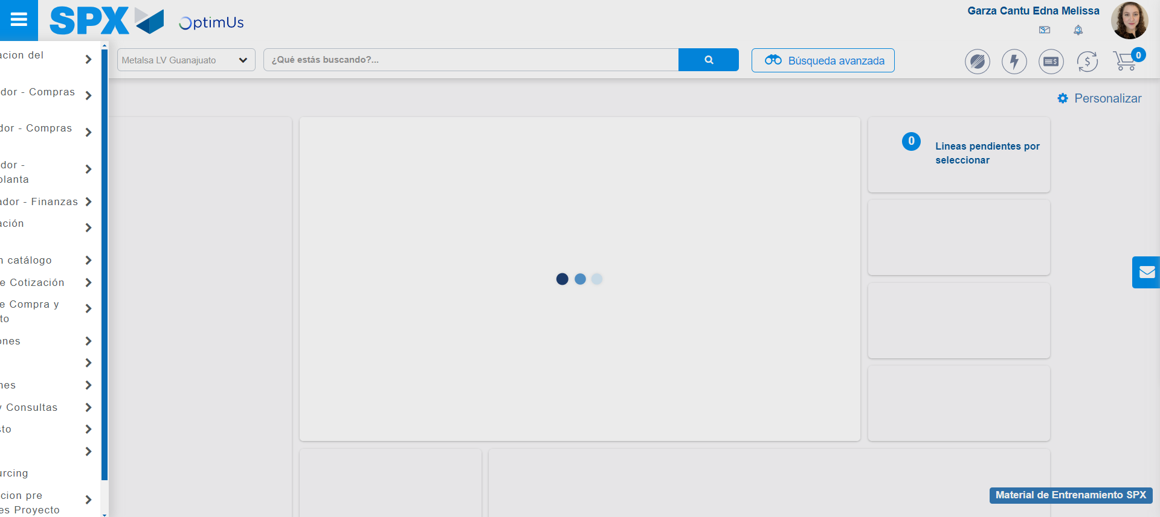Image file-name: QC_Testing-tc001_SPX_Dev5_Validar_Filtro_Campo_MenuName_Administrador_Roles_Menu-may. 15 2024, 12 57 25 p. m.

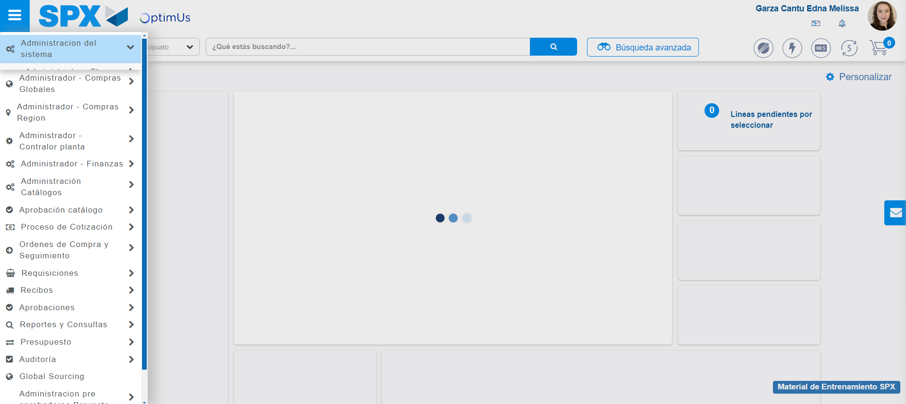Image file-name: QC_Testing-tc001_SPX_Dev5_Validar_Filtro_Campo_MenuName_Administrador_Roles_Menu-may. 15 2024, 12 57 26 p. m.

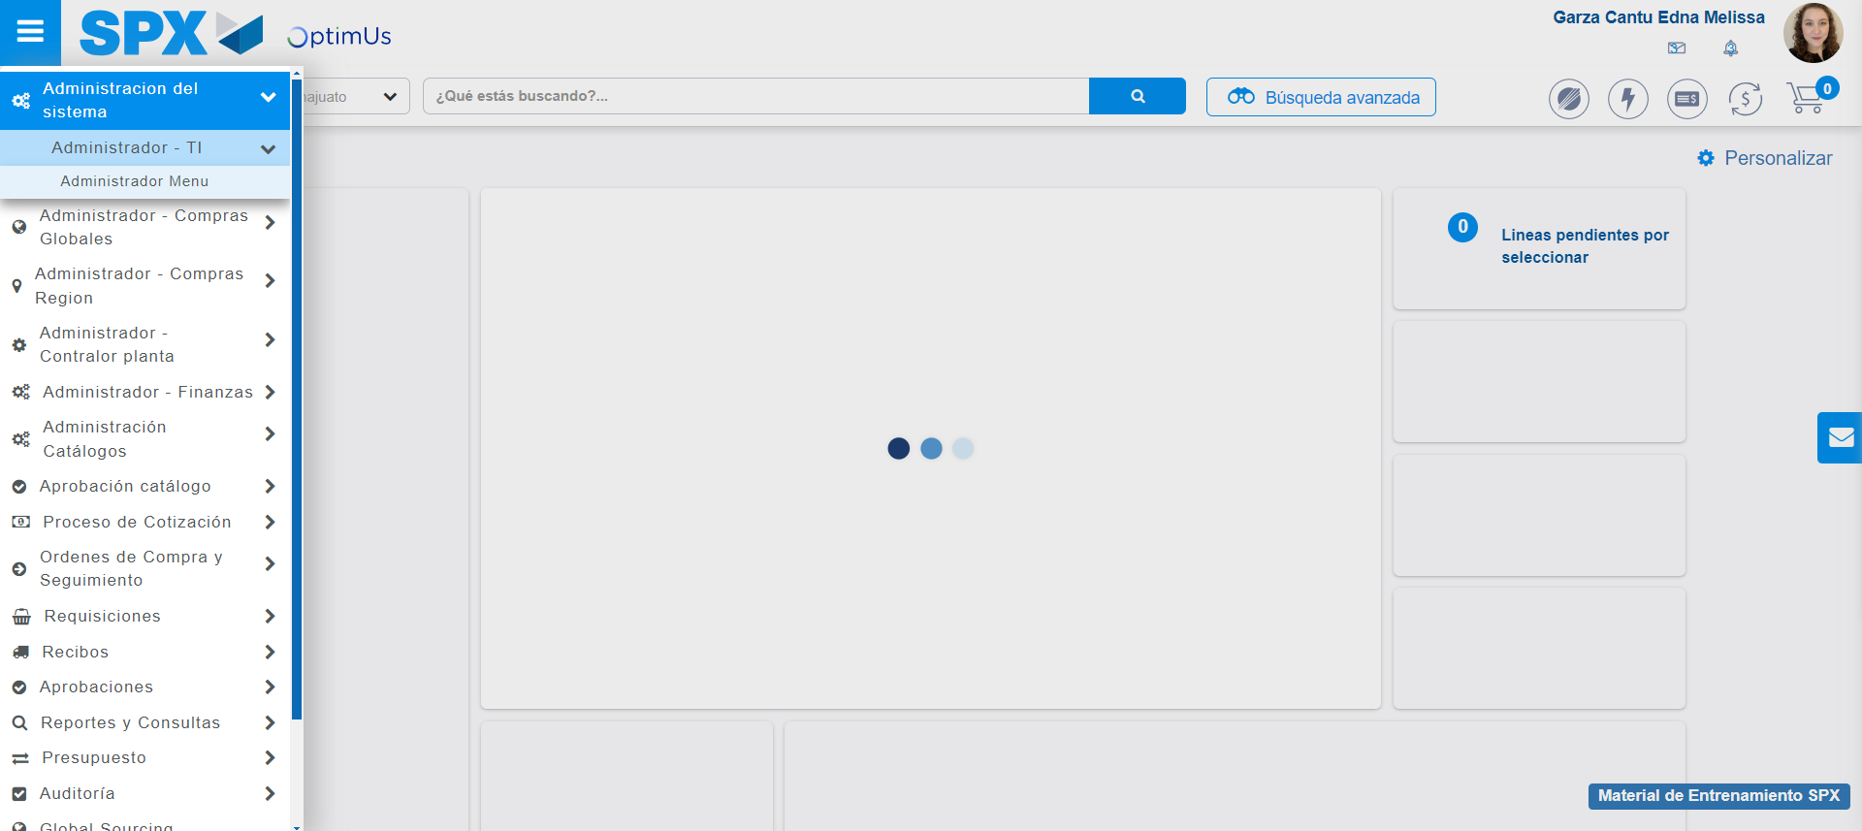Image file-name: QC_Testing-tc001_SPX_Dev5_Validar_Filtro_Campo_MenuName_Administrador_Roles_Menu-may. 15 2024, 12 57 27 p. m.

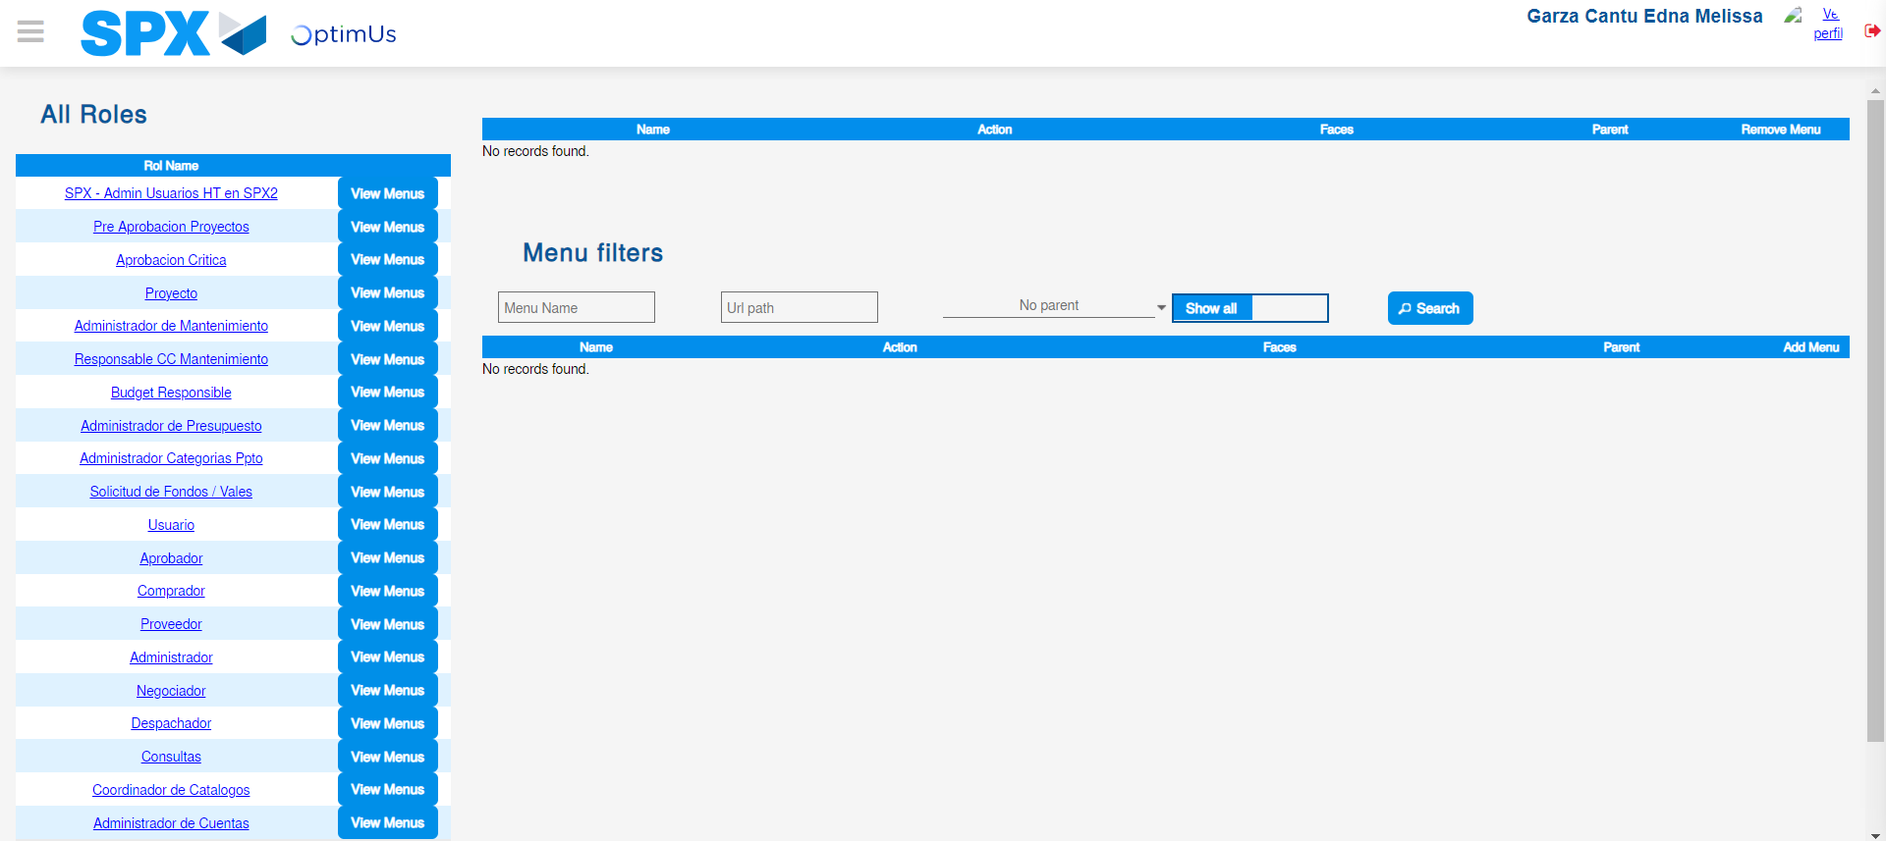Image file-name: QC_Testing-tc001_SPX_Dev5_Validar_Filtro_Campo_MenuName_Administrador_Roles_Menu-may. 15 2024, 12 57 32 p. m.

Step 3 - Click to Buttons View Menu and Search Filter with Menu Name: Correct Search
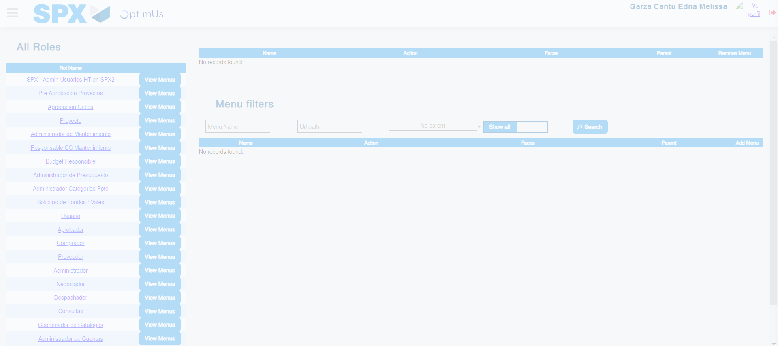Image file-name: QC_Testing-tc001_SPX_Dev5_Validar_Filtro_Campo_MenuName_Administrador_Roles_Menu-may. 15 2024, 12 57 33 p. m.

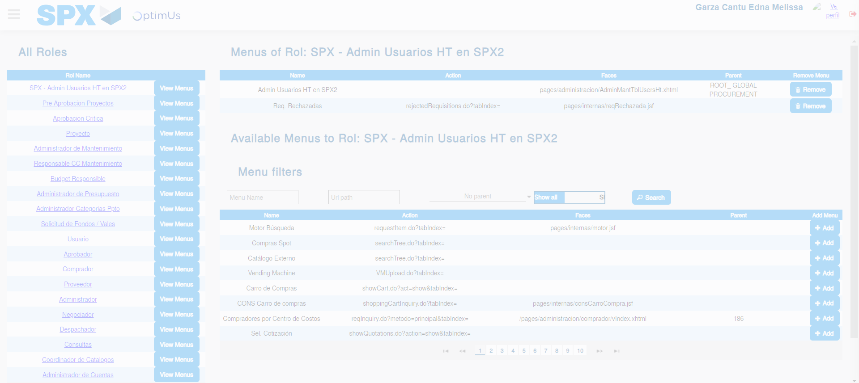Image file-name: QC_Testing-tc001_SPX_Dev5_Validar_Filtro_Campo_MenuName_Administrador_Roles_Menu-may. 15 2024, 12 57 34 p. m.

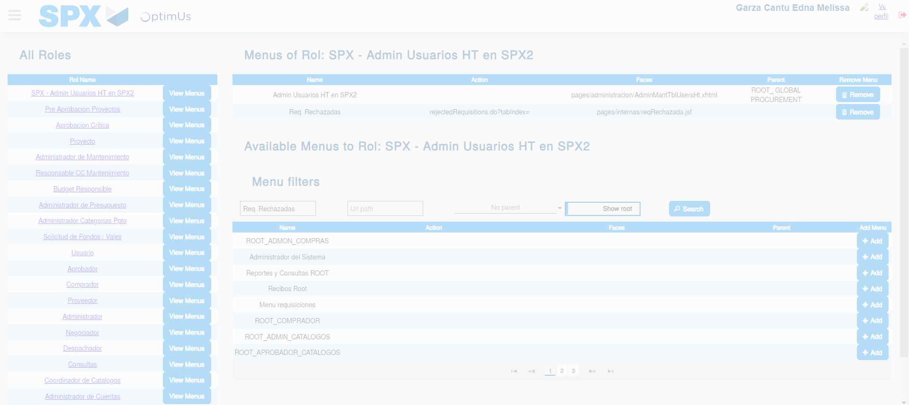Image file-name: QC_Testing-tc001_SPX_Dev5_Validar_Filtro_Campo_MenuName_Administrador_Roles_Menu-may. 15 2024, 12 57 35 p. m.

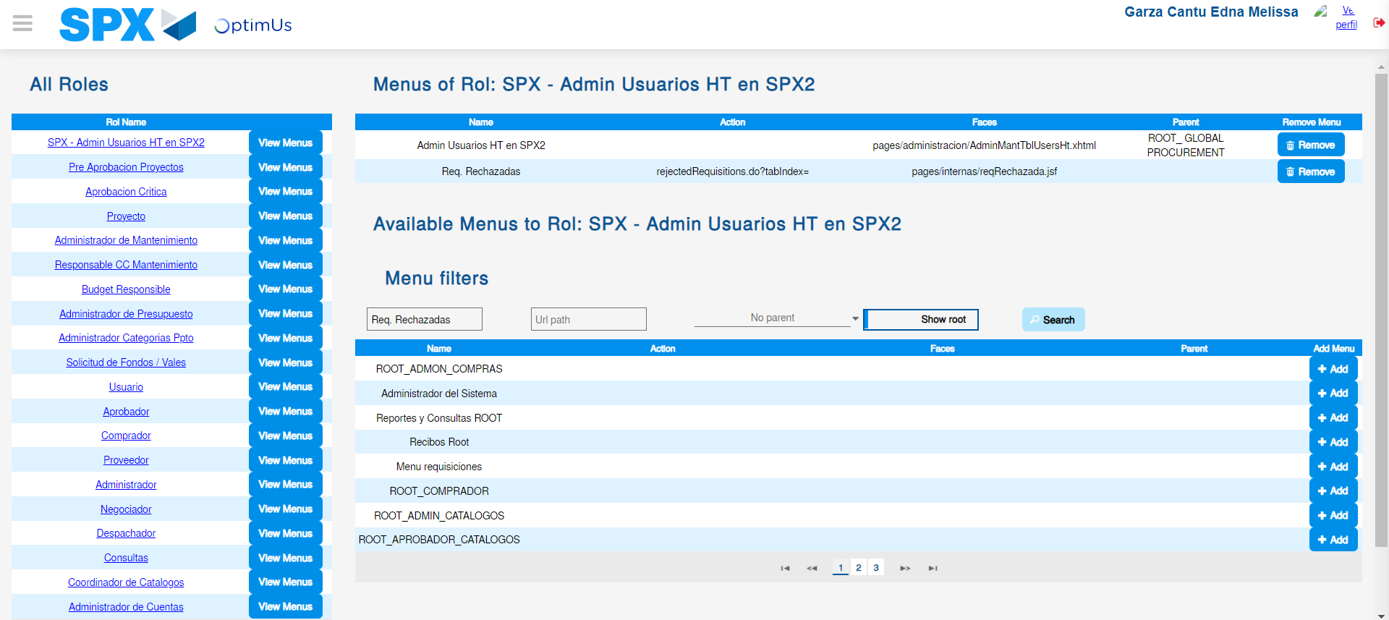Image file-name: QC_Testing-tc001_SPX_Dev5_Validar_Filtro_Campo_MenuName_Administrador_Roles_Menu-may. 15 2024, 12 57 36 p. m.

